Human Dynamics Survey
Age___ Grade___ Male___ Female___
- Do you think that woman should stay at home with their kids?
Yes ___ No___
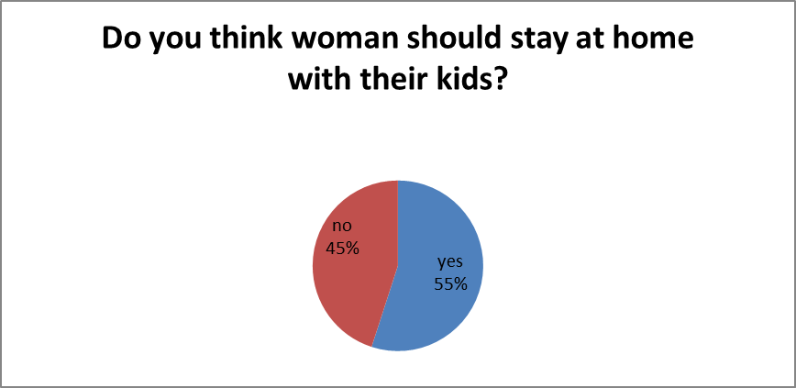
- Should woman have more rights in any kind of workforce?
Yes ___ No___
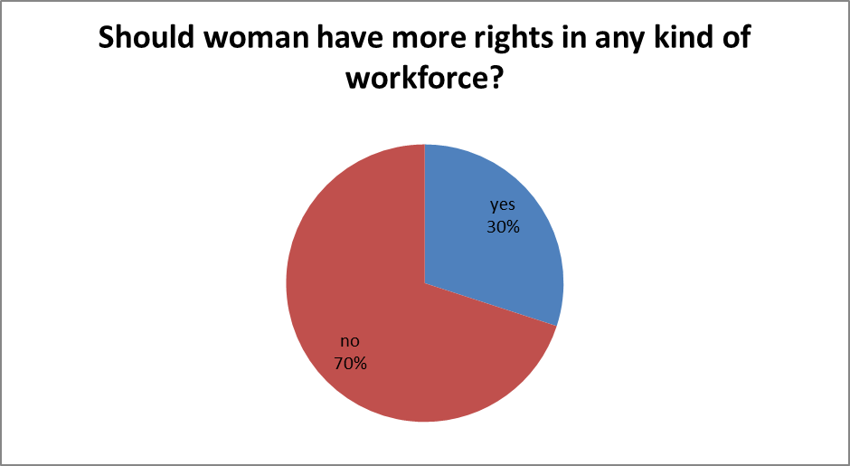
- Do you think that woman can do any kind of job they want?
Yes ___ No___
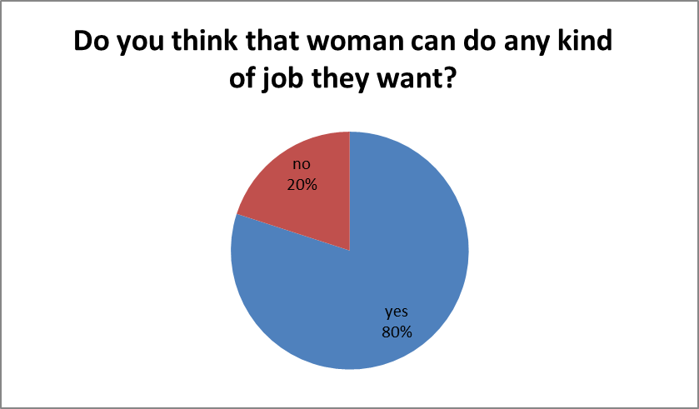
- Do you think the government should give more support to stay at home moms?
Yes ___ No___
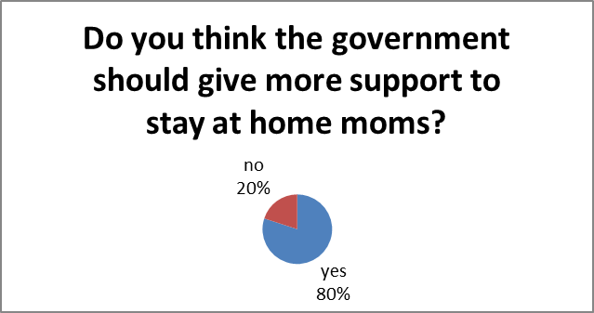
- Do you think women should get paid less then men in any job?
Yes ___ No___
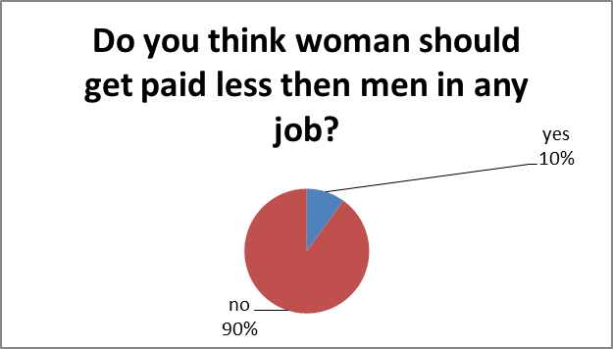

- Is your mother employed?
Yes ___ No___
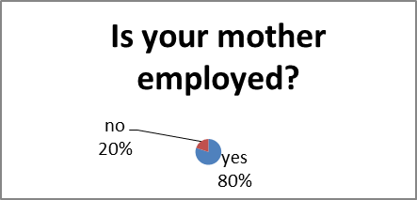
- Is your mother the breadwinner of your family?
Yes ___ No___
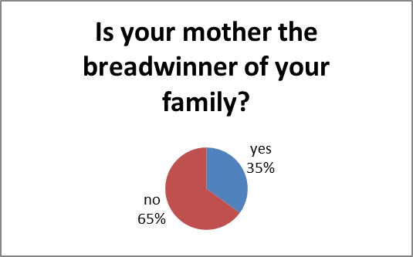
- Do you know a woman that works in any kind of trade such as construction industry?
Yes ___ No___
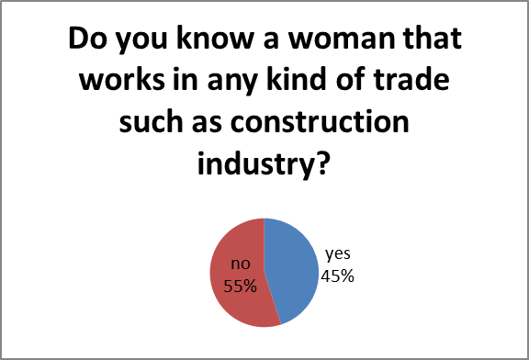
- Do you think woman are stereotyped in the workforce?
yes ___ No___
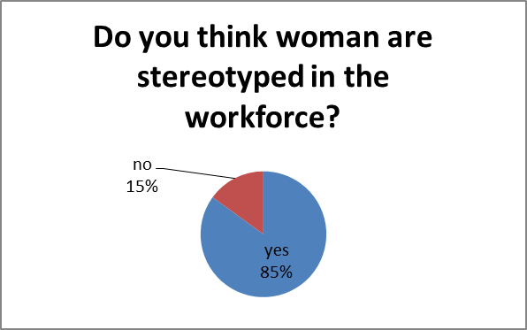
- Would you treat your boss any different if it was a female?
Yes ___ No___
