- Remove the oil drain plug using the 10mm wrench or socket and drain the oil from the crankcase/base into a suitable container. Removing the oil level indicator (dipstick) will let the oil flow out faster. Screw the drain plug back into the crankcase/base after the oil is completely drained.
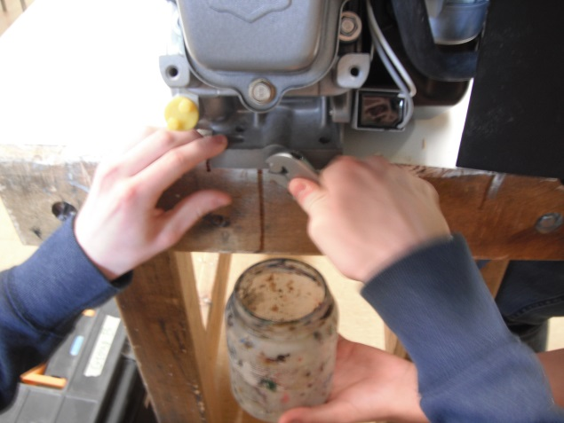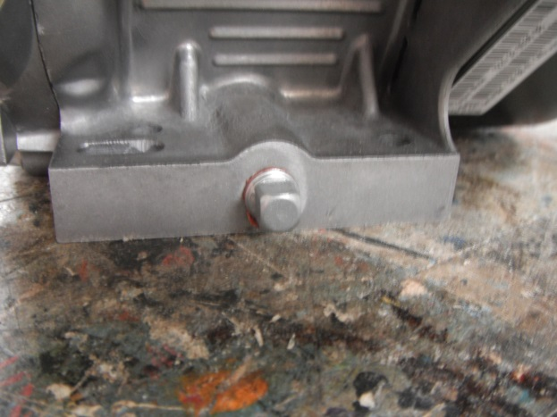
- Remove all fuel from the fuel tank and store in an appropriate container.
- Turn fuel shutoff switch to OFF.
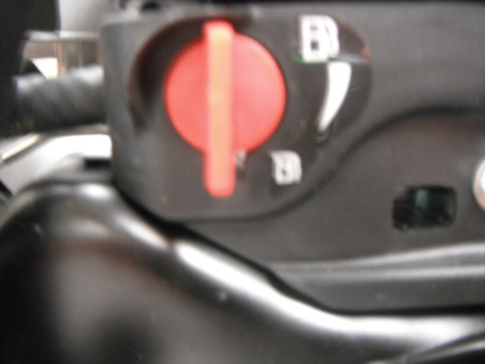

- Remove the spark plug wire cap from the spark plug.
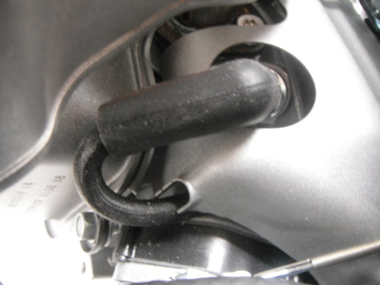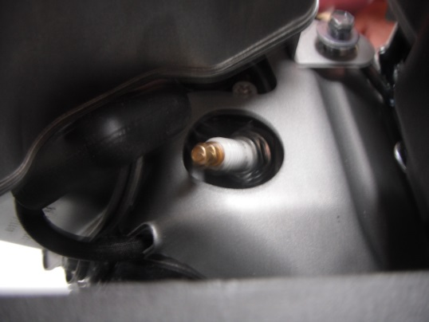
- Remove the plastic air cleaner/filter cover using a flat top screw driver or 8mm wrench or socket. Note the position of the green foam air filter precleaner and the paper air filter cartridge.
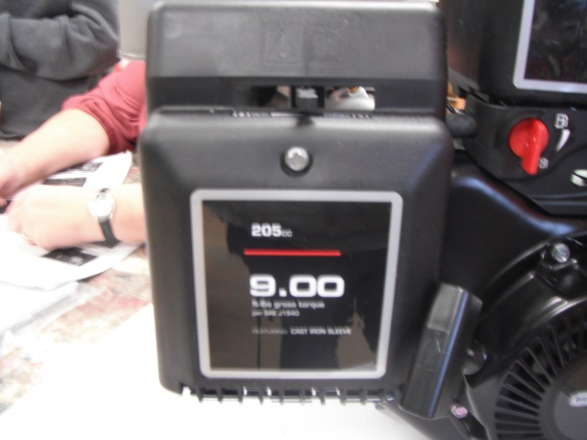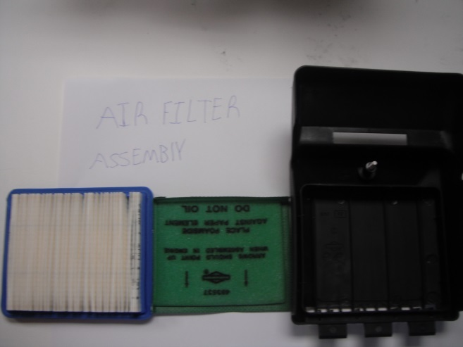
- Move the choke lever to the closed position to prevent dirt from entering the carburetor.
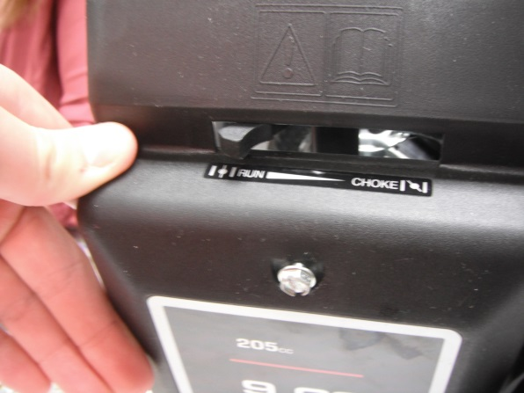
- Remove the 2 bolts attaching back plate from the carburetor using a 8mm wrench or socket. Note the position of the gasket between the back plate and the carburetor .reattach the 2 bolts back in the carburetor
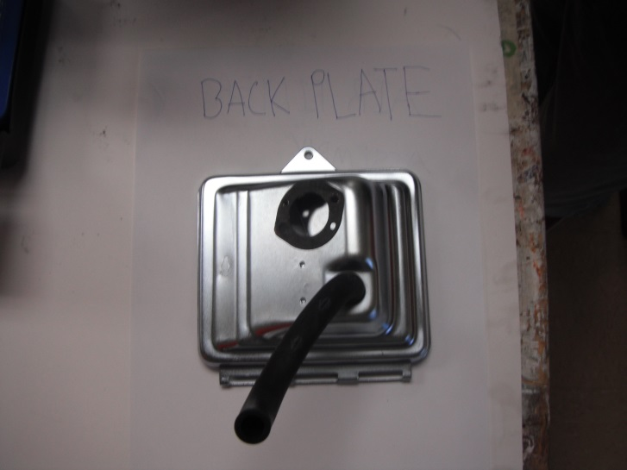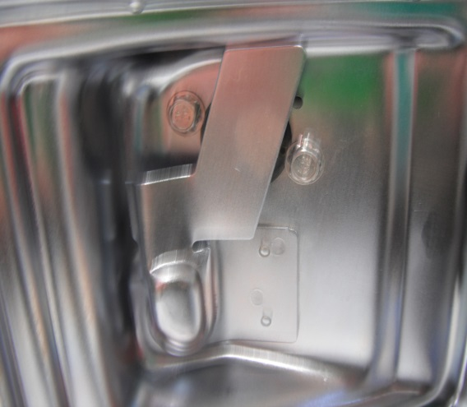

- Remove the black air line from the back of the plate
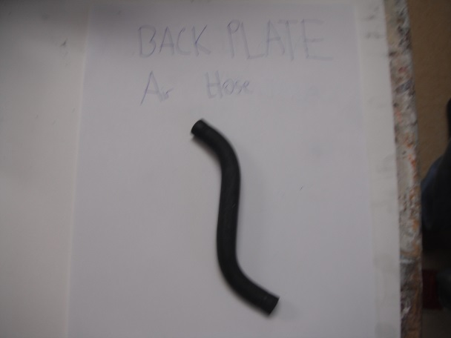

- Remove the 4 screws and the bolt attaching the exhaust/muffler heat shield using a 7mm wrench for exhaust and the 10 mm wrench or socket for the bolt.
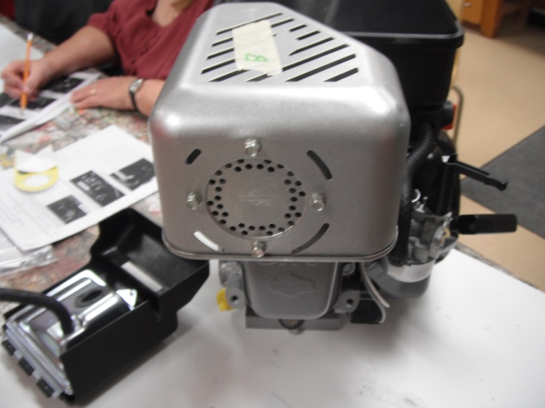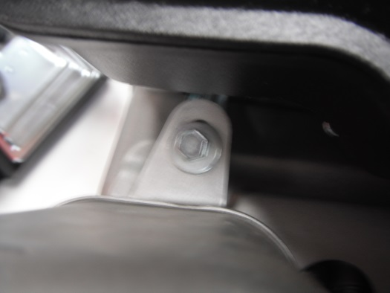
10. Remove the 2 bolts attaching the muffler using a 10 mm wrench or socket/ torque socket. Note the positions of the gasket between the muffler and the cylinder head. Reattach the bolts to the cylinder. Be careful NOT to lose them into the cylinder head.
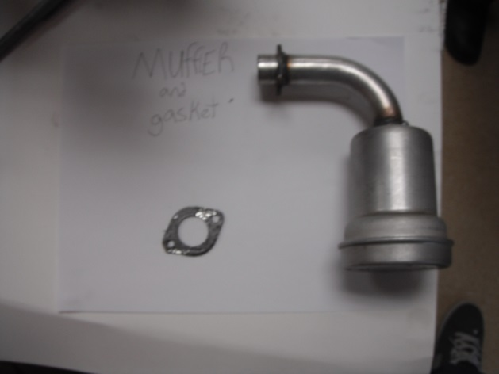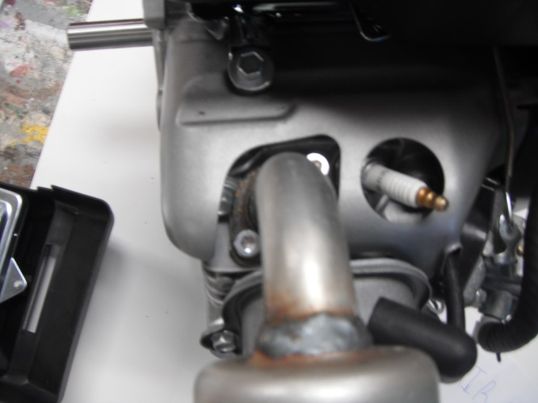

11. Remove the 4 bolts from the recoil starter using a 8mm wrench or socket or a 5/16 socket. Reattach the 4 bolts to the flywheel cover.
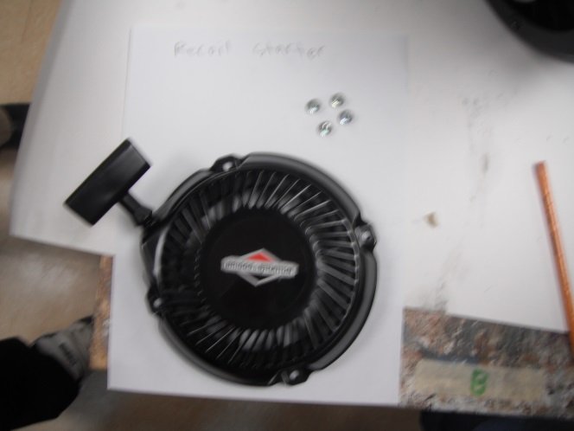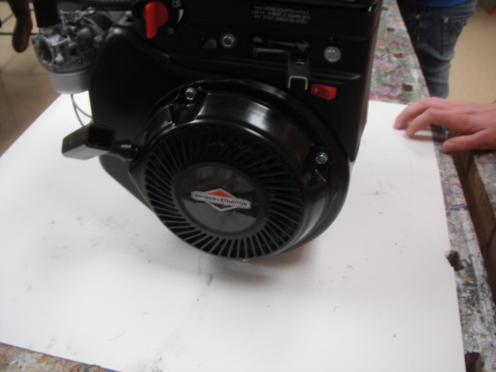
12. Move the speed control lever to the middle position. Remove the 3 bolts from the plastic fuel shutoff/speed control/ignition switch cover using an 8mm wrench, socket or 5/16 socket.
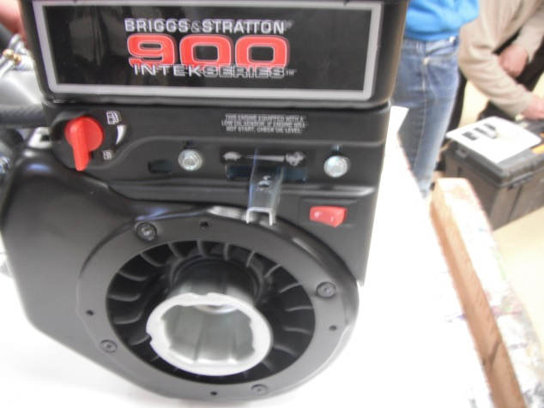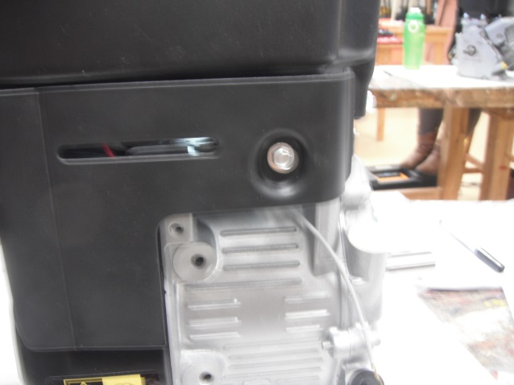

13. CAREFULLY remove the plastic cover taking care not to damage the 3 wires connected to it. Note the position of each color wire.
- Red wire is on the right of the on position
- White wire is on the left of the off position
- Black wire is in the middle
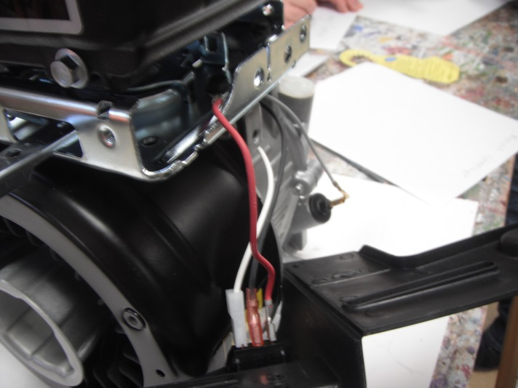
14. Disconnect the 3 wires using a pair of pilers. Do this gently.
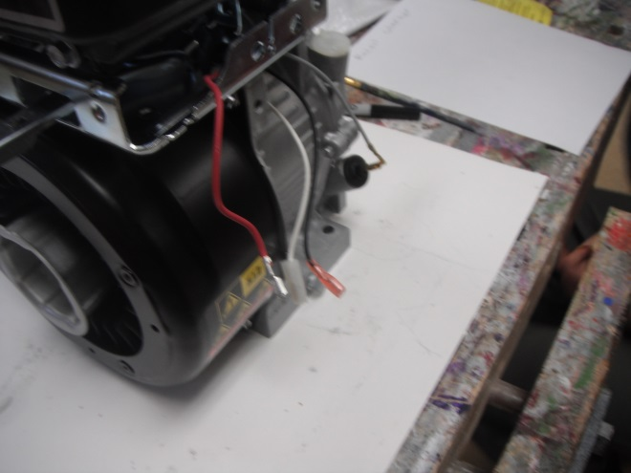

15. Screw the 3 bolts back in.
16. Remove the bolt attachimsor relay using a 10mm wrench or socket. Note the shape of the top of the bolt. Do not screw this to the flywheel cover until you remove the bolt next to it.
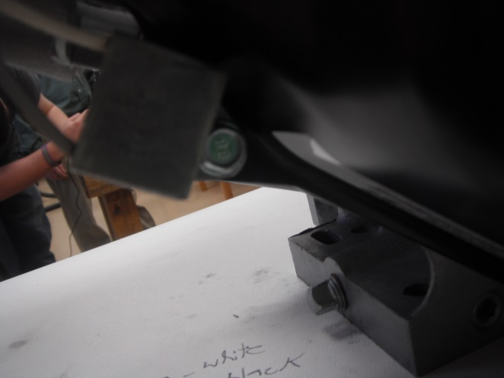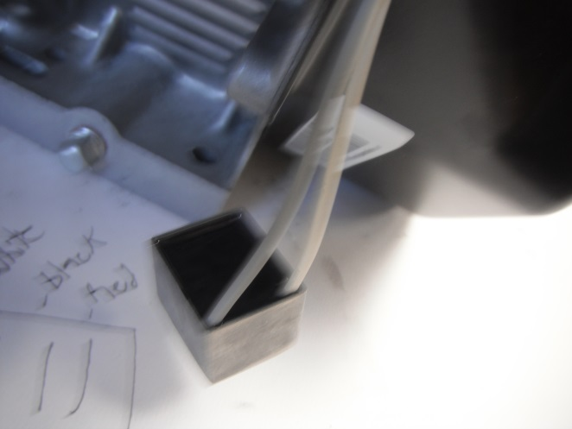
17. Remove the 3 remaining bolts connecting the flywheel cover to the engine block using a 10 mm wrench or socket. Screw the bolt attaching the oil sensor into the flywheel cover. Screw the 3 bolts back into the engine.
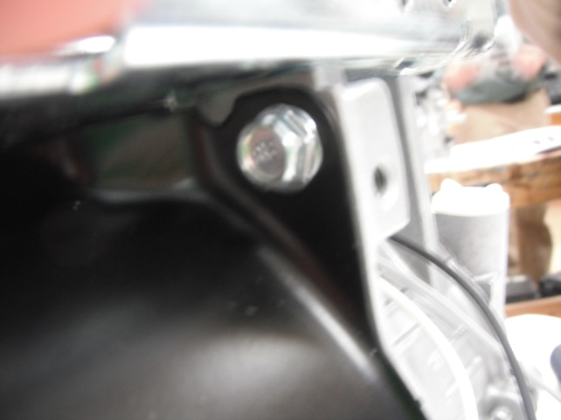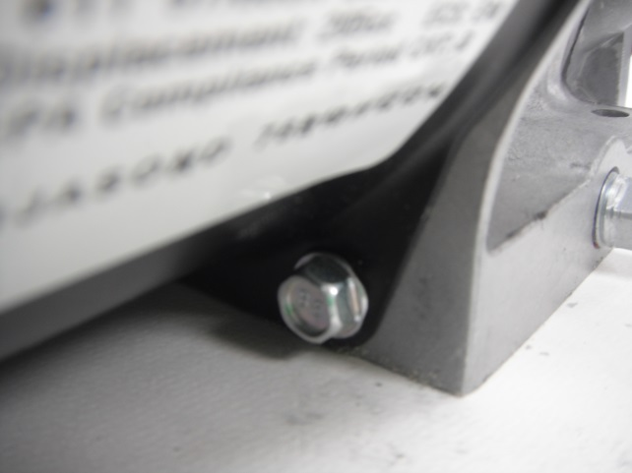

18. Remove the 4 bolts attached to the fuel tank using a 10 mm wrench or socket. Note the shoulder on each bolt.
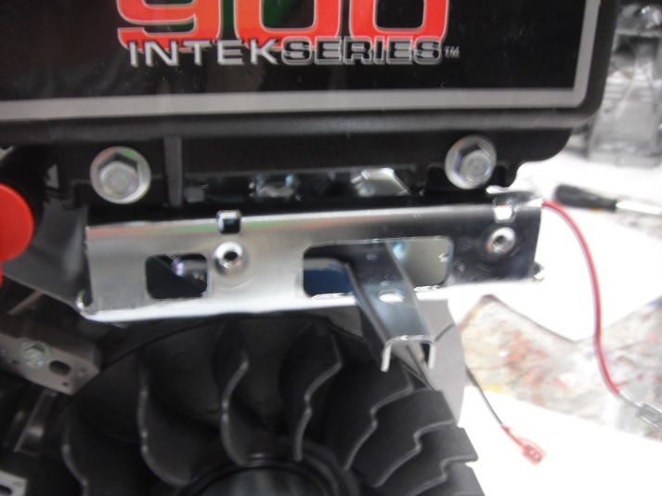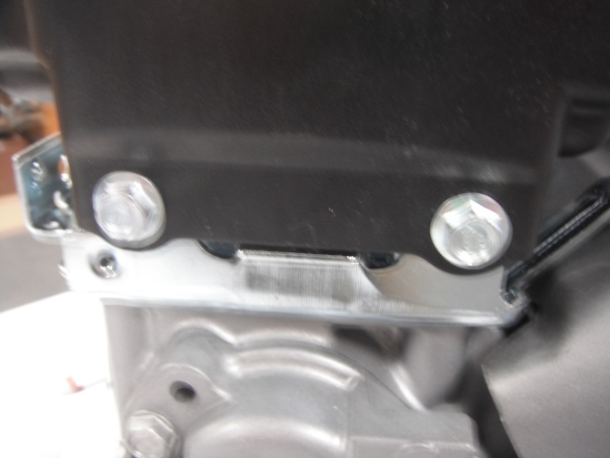
19. Remove the fuel line from the carburetor using pliers. Put bolts attaching the fuel tank back into the frame
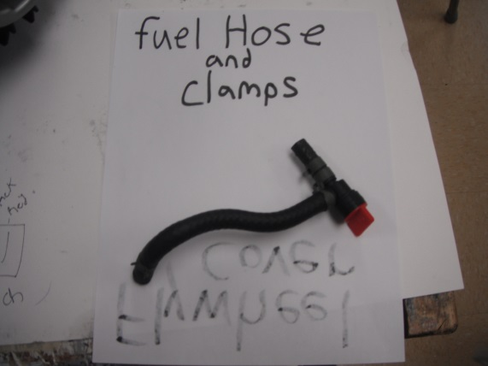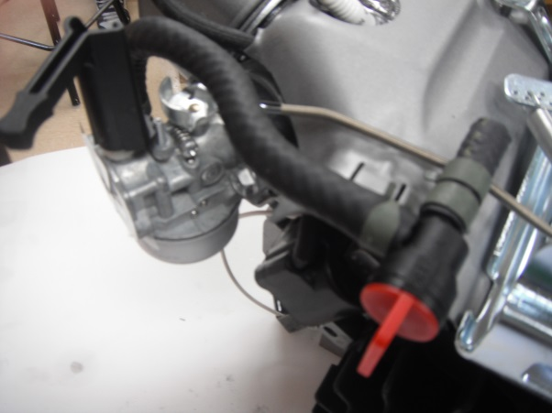

20. Carefully remove the 2 bolts attaching the carburetor using the 10 mm wrench or socket or a torque socket. Note the positions of the gaskets and the spacer which fit between the carburetor and the cylinder head.

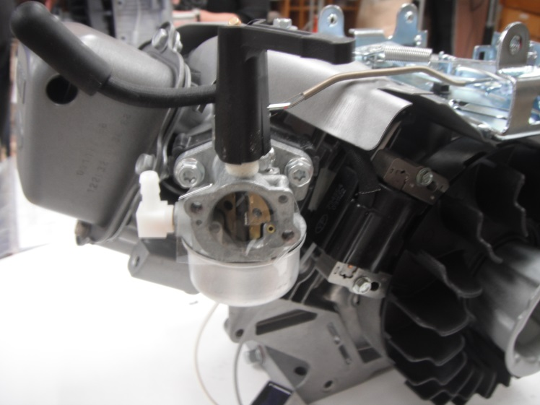
21. VERY carefully remove the linkage and the spring attached to the carburetor
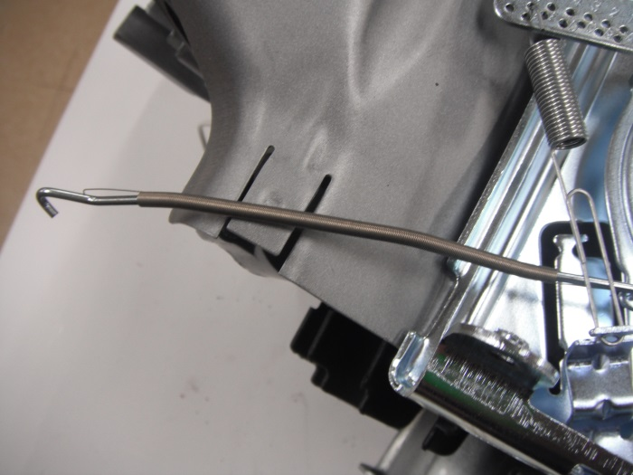

22. Screw the 2 bolts attaching the carburetor back into the cylinder head.
23. Note the position and orientation of the governor spring and carefully remove the end attached to the speed control lever.
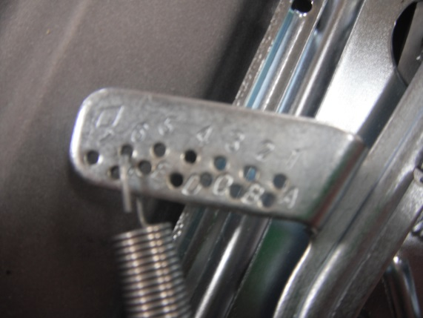
24. Note the orientation of the second spring and remove it from the governor using pliers.(see diagram below)
25. Loosen the nut that secures the end of the governor lever to the post attached to the frame using a 10 mm wrench or socket. Note the position of the shaft on the post.
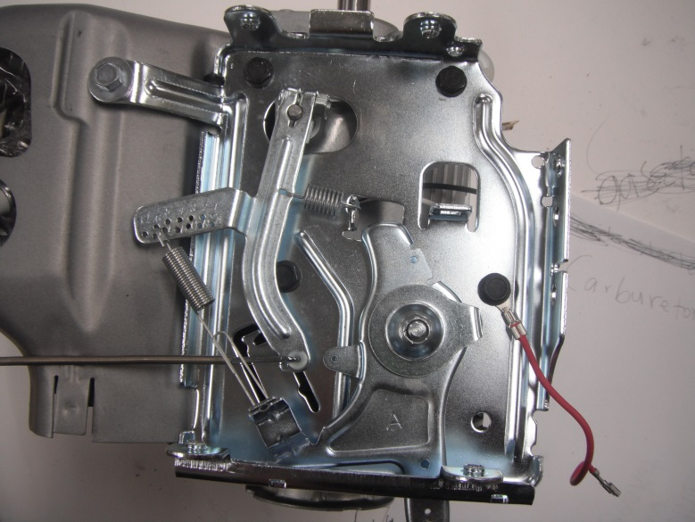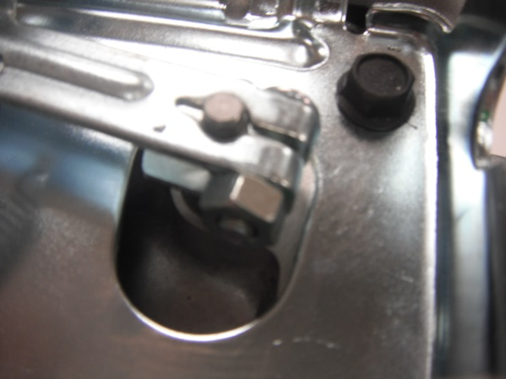
26. Gently enlarge the spacing on the end of the lever with pliers and remove the lever from the shaft.
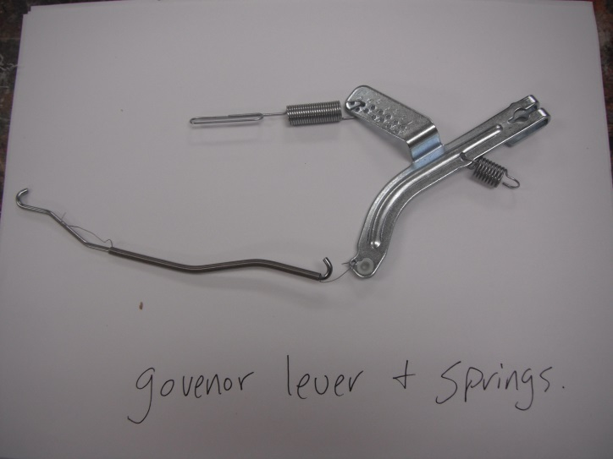
27. Remove the 4 bolts attaching the frame to the cylinder using a 10mm wrench or socket. Note the positionof the red ground wire. Screw the 4 bolts into the engine block with the red ground wire on the correct bolt.
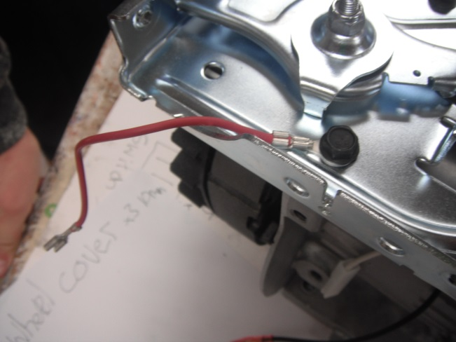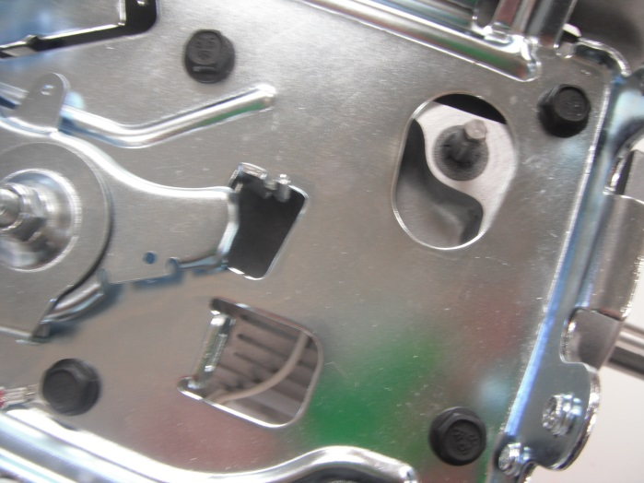

28. Remove the bolt attaching the heat shield between the cylinder head/cylinder and the engine frame using a 7mm wrench or socket. Screw the bolt back into the cylinder.
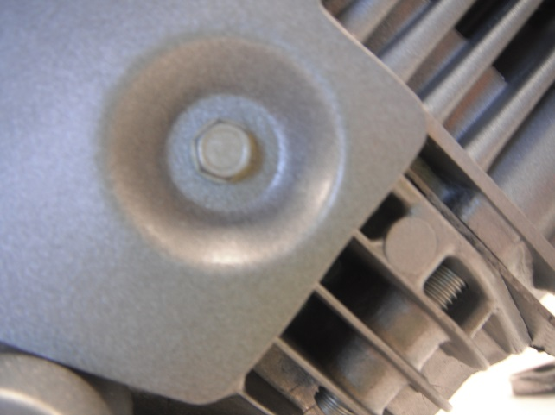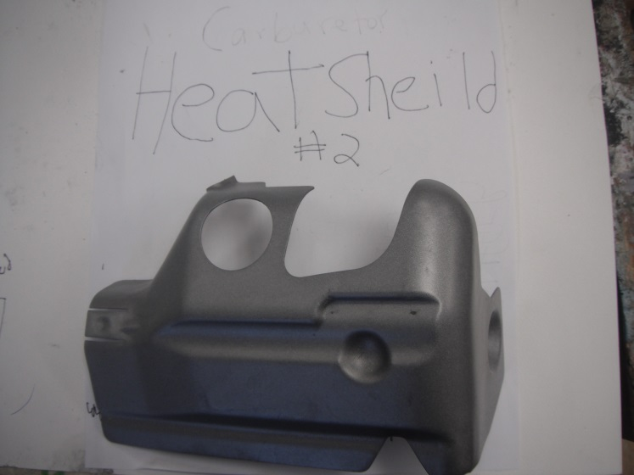

29. Remove the gray wire from the oil level sensor using pliers. Remove the oil sensor relay.
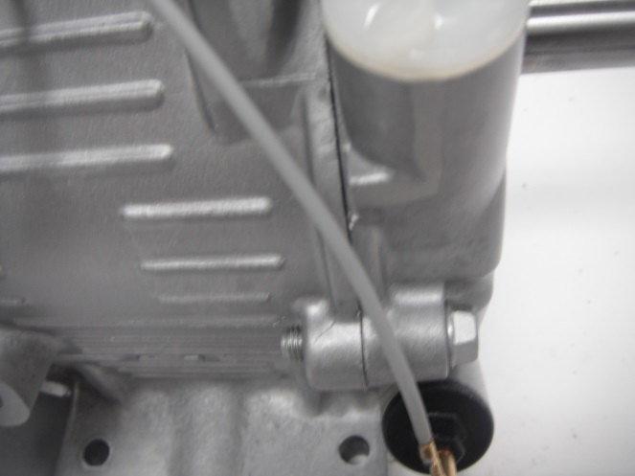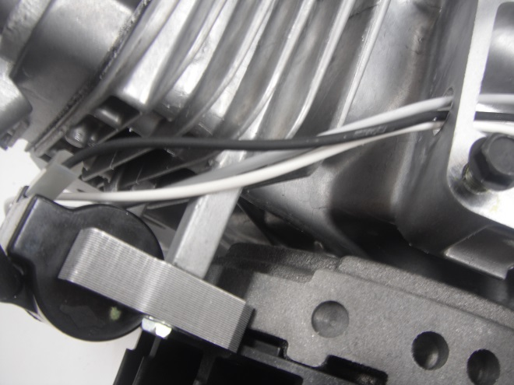

30. Remove the 2 bolts attaching the ignition armature(coil) using a 7 mm wrench or socket. Screw the bolts back into the cylinder.
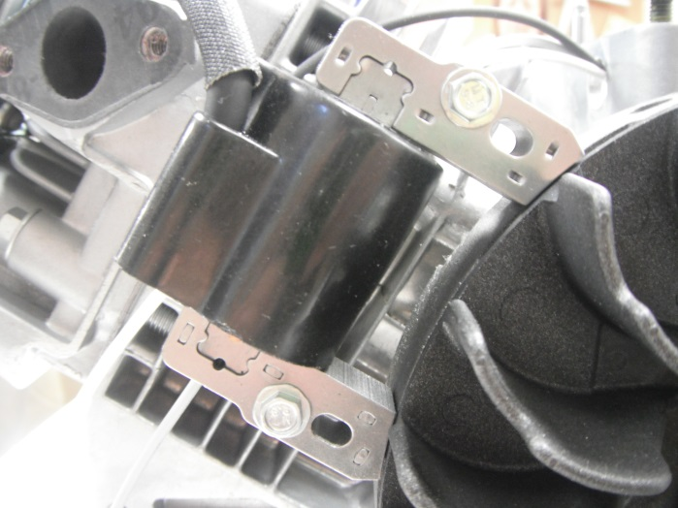
31. Remove the flywheel nut and cup using a 24mm socket with the extension. Also use the flywheel holder and a pipe to put over ratchet to get more leverage. Pull off plastic flywheel fins.
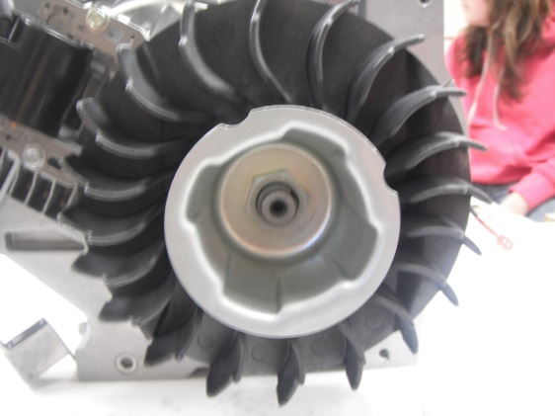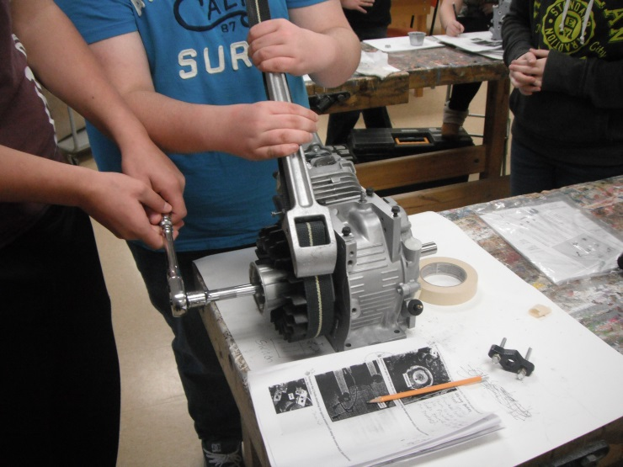

32. Remove the flywheel using a crowbar to put behind the flywheel and edge out all around. Be careful as the flywheel may come loose quickly. As well, the flywheel pin is small and easy to lose.
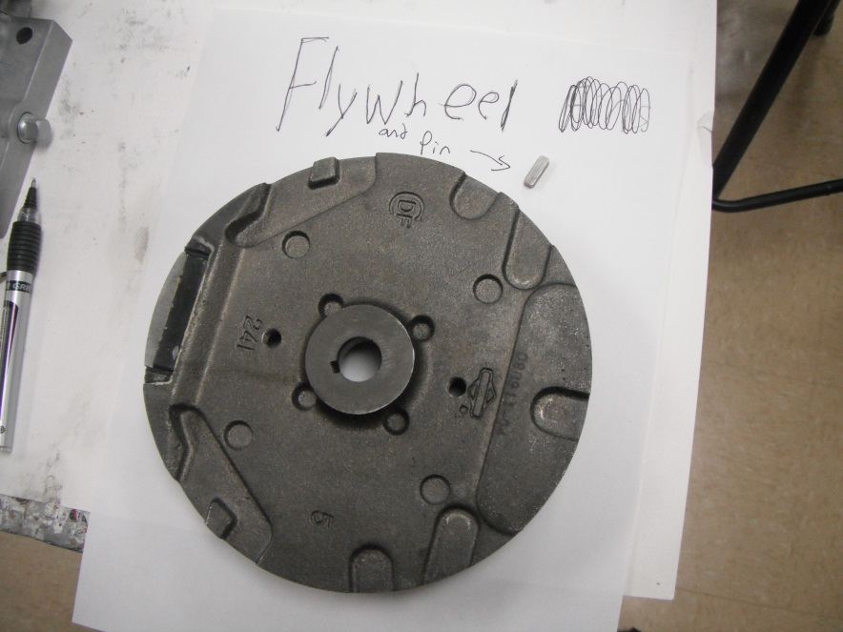

33. Remove the 4 bolts from the valve cover using a 10 mm socket or wrench. Note the symbols on the top of the bolts and their positions. (longer bolt is on the bottom). Note the position of the gasket between the cover and cylinder head. Screw the 4 bolts back into the cylinder head.
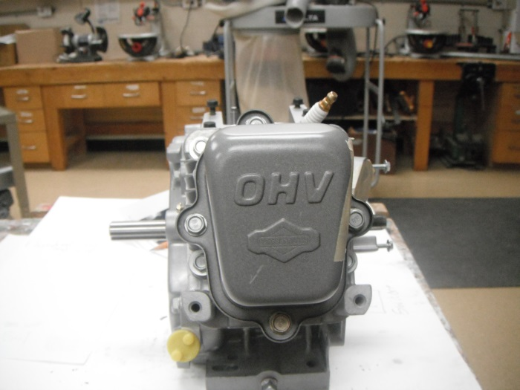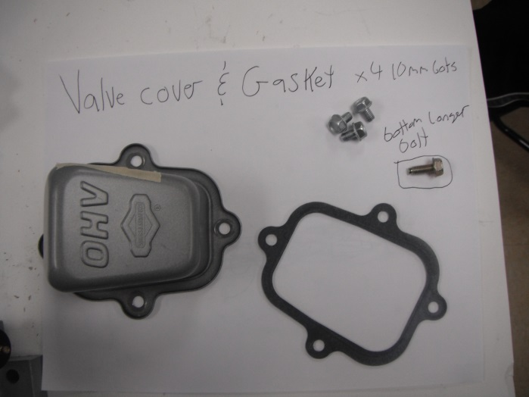
34. Remove the 4 cylinder head bolts using a 7mm socket or wrench.
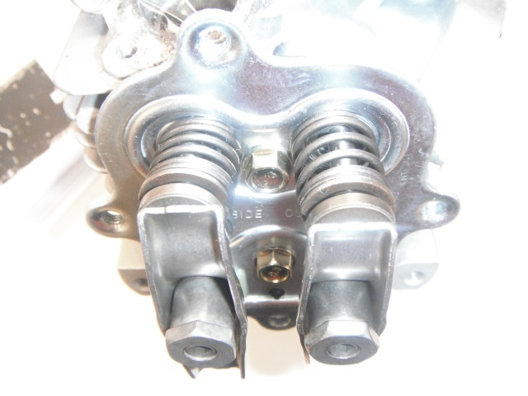

35. Very carefully remove the cylinder head being careful not to bend the valve push rods and to not lose the caps under the rocker arms on the ends of the valve stems.Note the position of the gasket between the cylinder head and the cylinder. Remove the valve push rods and screw the 4 bolts back into the cylinder head.
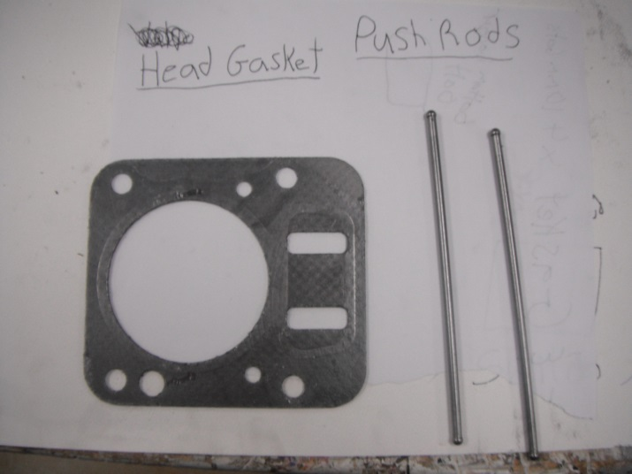
36. Remove spark plug with 5/8 socket.
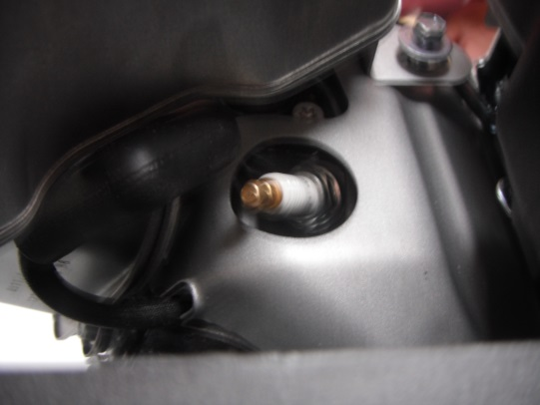

37.Remove valves using Valve spring compressor or pushing down on the valve with your thumbs. Slide valve keeper to one side to remove the spring.
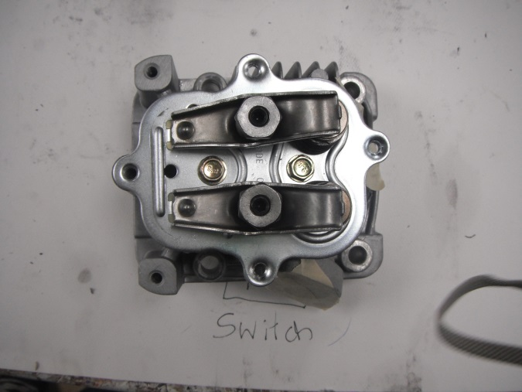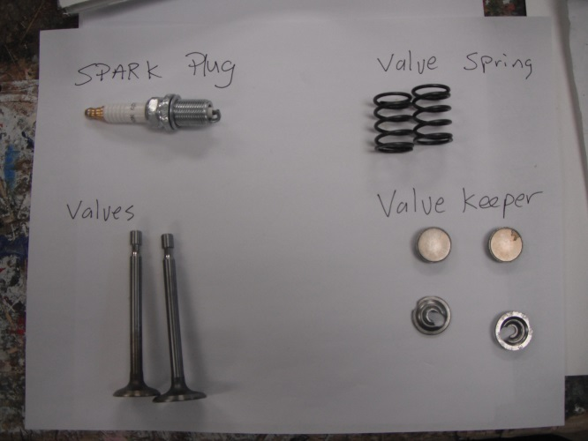

38. Remove valve assembly plate with 10 mm wrench or socket.
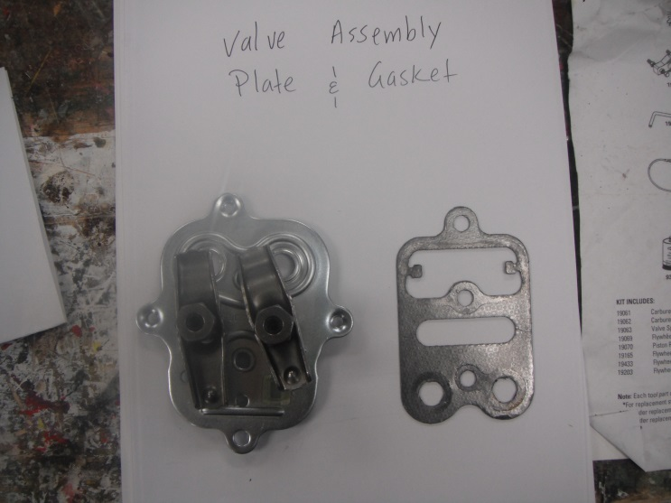

39. Remove the 6 bolts from the crankcase cover using a 10 mm wrench or socket.
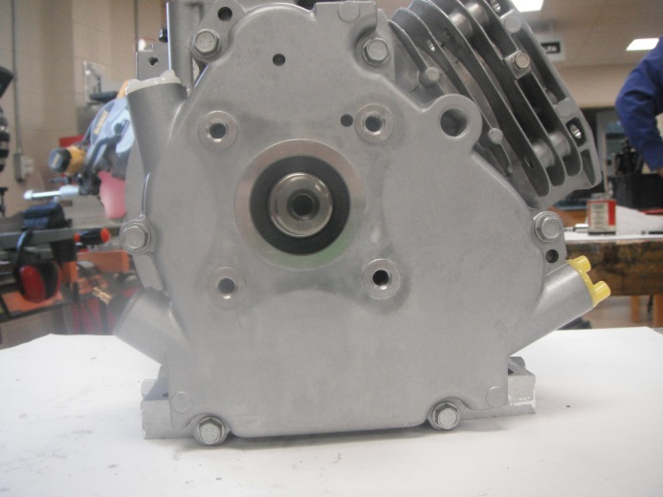
40. VERY carefully remove the crankcase cover taking great care not to damage the gasket between the cover and the crankcase. If there is any oil still in the crankcase/base it will leak out. Note the position of the oil level sensor,the oil-slinger assembly and the bearing on the inside of the crankcase cover. Screw the 6 bolts back into the crankcase.

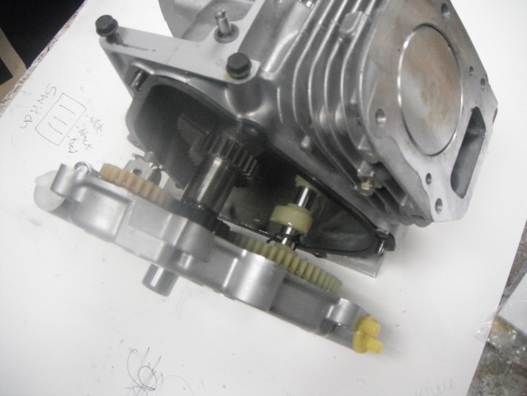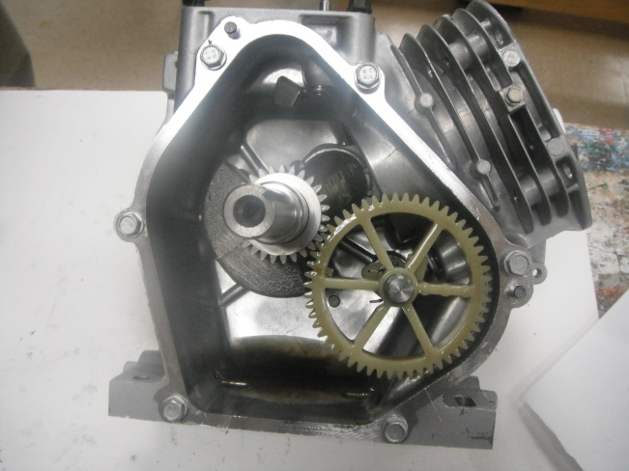

41. Rotate the crankshaft until you can carefully remove the camshaft. Note the larger plastic gear and the two plastic cams located on the camshaft. Remove the 2 valve lifters. Look inside the crankcase and located the oil dipper, crankshaft, connecting rod and connecting rod cover.

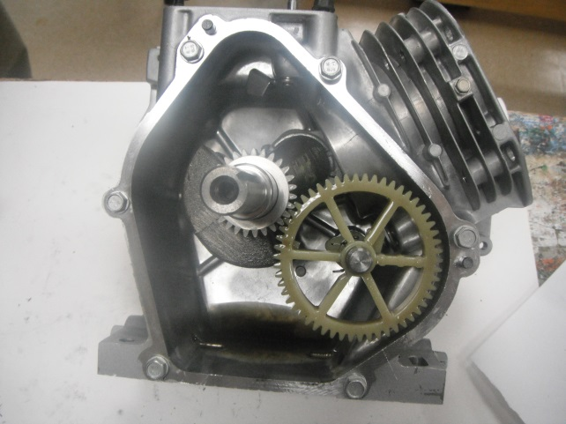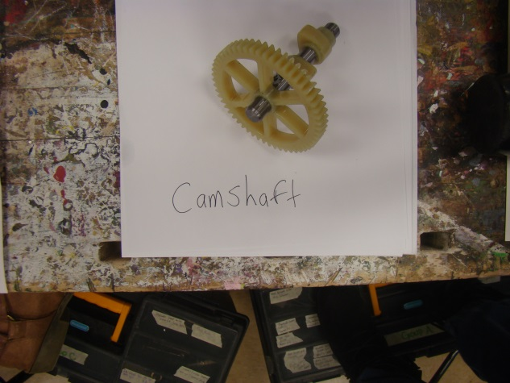
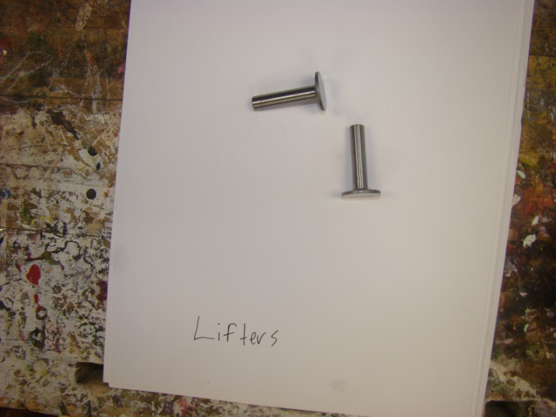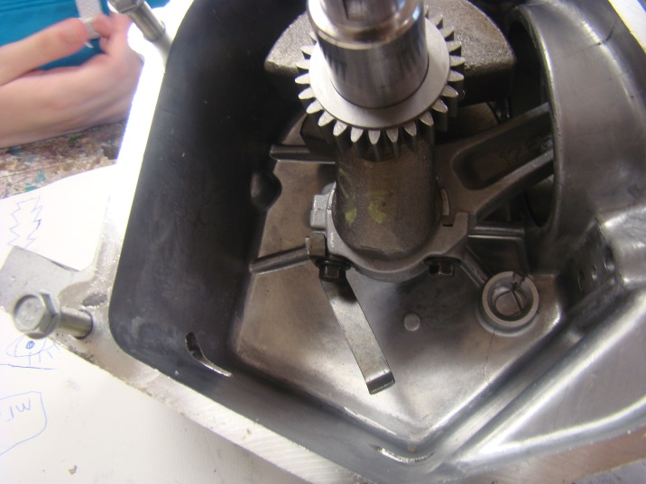

42. Remove the 2 bolts attaching the connecting rod cap and the oil dipper to the connecting rod using the 8mm wrench. Remove connecting rod cap, noting the way the cap attaches to the connecting rod. Also note the position of the crankshaft and connecting rod.
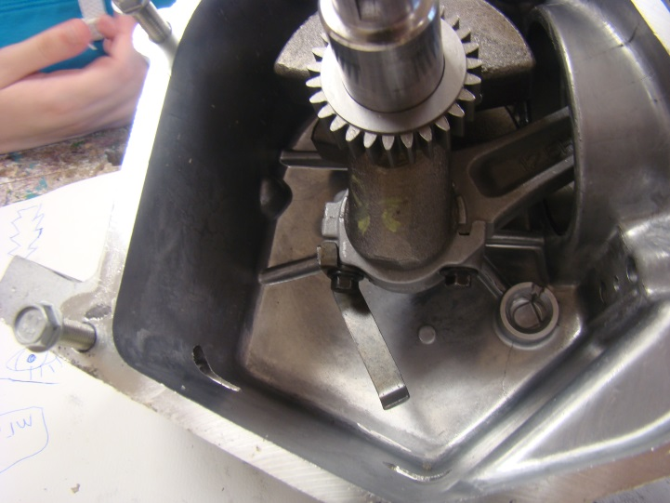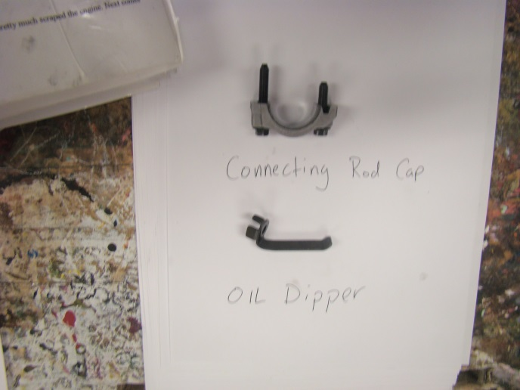
43. Turn the crankshaft until the piston reaches TDC. Note the numbers etched into the top of the piston and the location of the notch in the piston relative to the side of the engine (flywheel side).

44. Push the piston out of the cylinder. Note the number of piston rings and their position. (Ex. Ported ring on bottom). Note the number stamped into the connecting rod.
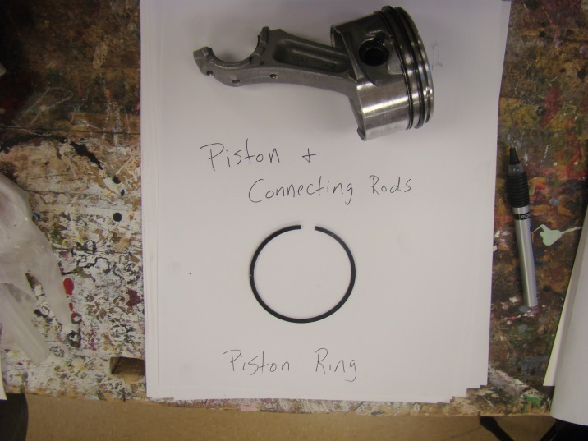
45.Carefully remove the crankshaft and the crankshaft gear and spacer.
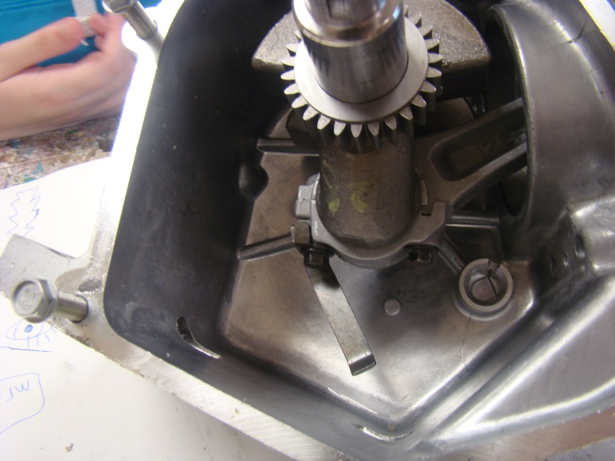

46. Remove the crankshaft gear and spacer from the crankshaft noting the order in which both are removed and the location of the indentation on the gear relative to the side of the engine.
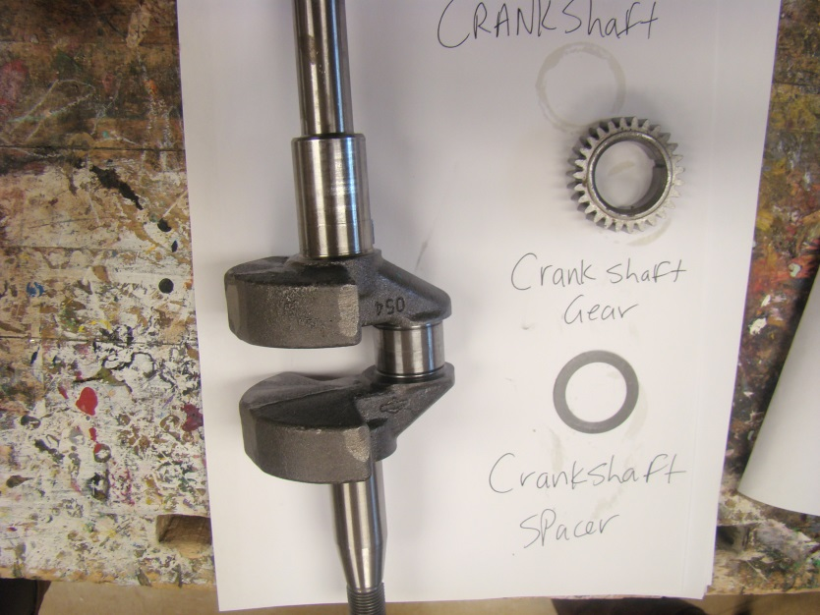
47. Other than dissembling the cylinder head, you have now pretty much scraped the engine. Next comes dissembling the cylinder head and carburetor.

